SUMMER READING
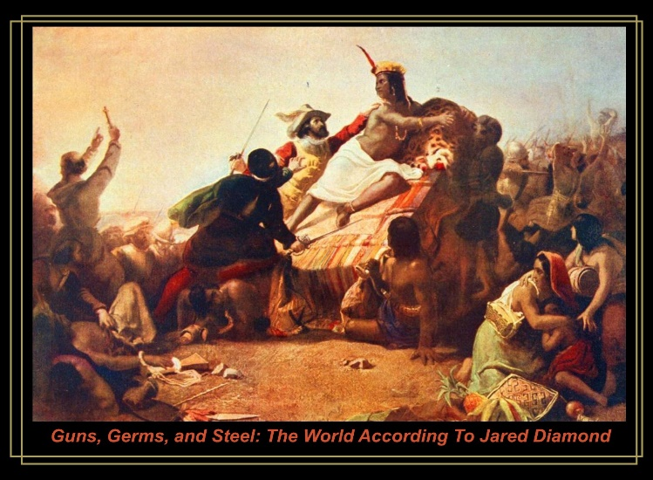
- Guns, Germs and Steel (1997) Diamond, J. Please read the Prologue – Yali’s Question (Pg. 13 -32); Chapter 1 – Up to the Starting Line (Pg. 35-52); Chapter 5 – History’s Haves and Have-Nots (pg. 93 – 103). We will be grappling with the question: “Why have some societies been able to conquer others?” There are many potential answers to this question, which many thinkers across numerous disciplines have pondered. In the early part of our course we will be examining how the Pulitzer Prize winning author, Jared Diamond went about answering this provocative question. Diamond’s theories are particularly alluring (and not without controversy).
You will start with the three chapters above that I have outlined and we will be delving deeper into this book – so you will need to have it. Order and read the chapters I have assigned (or listen to it as a book-on-tape). We will be reading other selected chapters, as well as doing group presentations.
Please come to our first class with both written and verbal evidence of your engagement with Guns, Germs and Steel. In other words, I’ll ask you to talk me through your notes. You should annotate (take notes) in a way that works for you, but I would recommend writing your notes by hand and keeping them all in one place. Notes are not copying and pasting other peoples’ summaries or analysis of the text, but rather they are your attempt to distill what you’ve learned into your own words. Of course, you may include quotations, but then demonstrate that you understand the quotations you’ve included.
This summer our focus should be on annotating and engaging – I will be doing the same! Don’t hesitate to contact me with any questions that arise. (jjohnson@christchurchschool.org). I look forward to our first meeting on Thursday 2 September as we begin an interesting and transformative journey together.

